TIME SHEET DOMAIN
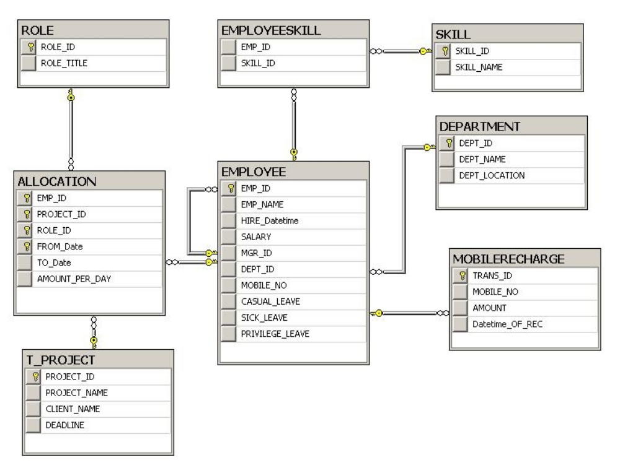

SQL

1.Which PROJECT has maximum number of EMPLOYEES?
2.Which EMPLOYEE has not yet been allocated to any PROJECT?
3.Which role played by the employee 'E03' frequently?
4.Which is the costliest Project?
5.How many employees were there in costliest Project?
6.Which is the cheapest Project in the year 2012?
7.What is the salary of employee, who played maximum roles in Project 'P07'?
8.How many projects are handled by senior most employee?
9.What is the total amount spent for unassigned employees?
10.How many projects are completed till date (Assume to_date is completion date in Allocation table)?

11.How many employees have worked for less than 10 Projects?
12.How many employees are working with role 'R02' in project 'P04'?
13.Which client has given maximum number of Projects?
14.Which employee has not been allocated to any project in the year 2010?
15.Find the total number of days worked by the employee 'E04' in project 'P02'?
16.Which Project has been completed exactly on deadline date?
17.How many employees were working for the Project, which has crossed the deadline?
18.Which Project has been completed so earlier?
19.Which Project has taken maximum duration?
20.Prepare a report in following format

Emp Id | Total Number of Days in bench

21.Prepare a report in following format

Project Name | Number of Employees

22.Prepare a report in following format

Role Name | Number of Employees

23.Prepare a report in following format

Emp Name | Number of Projects

24.Prepare a report in following format

Emp Name | Number of Roles

25.Prepare a report in this format

Role Name | Number of Employees

26.Prepare a report in this format

Role Name | Number of Projects

27.Prepare a report in this format

Emp Name | Role Name | Number of Projects

28.Prepare a report in this format

Project Name | Role Name | Number of Employees

29.Prepare a report in this format

Role Name | Emp Name | Number of Projects

30.Prepare a report in this format

Dept Id | Number of Employees

31.Prepare a report in this format

Mgr_id | Number of Employees

32.Prepare a report in this format

Emp Name | Role Name | Project Name

33.Prepare a report in this format

Project id | Emp id | Total Amount collected
Sort the report with respect to the Total Amount collected in Descending Order.

34.Prepare a report in this format

Emp id | Role id | Total Amount collected

35.Prepare a report in this format

Emp id | Role id | Project id | Total Amount collected
Sort the report with respect to the Total Amount collected in Descending Order.

36.Prepare a report in this format ?

Emp id | Mgr Id | Comments
123 | 432 | Has Manager
456 |  | No Manger
125 | 456 | Has Manger

If Manager id is NULL for an employee then the comment must be “No Manager “

37. Prepare a report in this format
Ram Works for Ashok
Adam works for Akbar

Where Ram is employee name and Ashok is his corresponding manager

38.Which employees earns more than his/her manager?
39.Which manager joined after his/her sub ordinates?

40.Using Correlated Subquery and WITH clause
Find all employees who earns more than the average salary of his/her department?
41. Using Correlated Subquery:
Display the details of employees who have changed their roles at least twice?
42.Display the departments that does not have employees(ALL POSSIBILITIES)?
43.Find the department which has employees(ALL POSSIBILITIES)?

44. Using ROLL UP and CUBE
Generate a report:

Project ID | Role ID | No of Employees

45. Using ROLL UP and CUBE
Generate a report:

Employee ID | Project ID | Total salary

46.Prepare a hierarchical report:

LEVEL EMPLOYEE
----------------------------------------
1 raja
2 anil
3 anjali

( hint: start with emp_name='raja' )

47.Using CASE/DECODE

Emp ID | Number of Skills | Description

If Employee have,
i) more than 5 no of skills: Description is “Major Resource”
ii) more than 3 no of skills : Description is “Useful Resource”
iii) more than 1 no of skills : Description is “Resource”

48. Generate a report :

Emp ID | No of leaves | Description
If no of leaves is greater than 6, Description is “Loss of Pay”
If no of leaves is less than or equal to 6, Description is “No loss of pay”
If no of leaves is equal to zero, Description is “Bonus”

49.List TOP 5 salaried Employees?
50.List TOP 3 Departments (with respect to maximum no of employees)?
51.For each Department display the 2nd maximum salary earner?
52.Generate a report:

Emp Name | Number of skills

53.Generate a report :

Emp Name | Number of recharges done so far

54.Delete duplicate rows from Employee table(Using ROWID)?

